**EXPERIMENT NO.4**

**AIM:** To study the G-M Codes for CNC machine and to perform different machining operations including facing, turning, grooving etc on CNC lathe

**Theory: -** **CNC stands for Computer Numerical Control.** When computers are used to control a Numerical Control (NC) machine tool the`n the machine is called CNC machine. In other words, the use of computers to control machine tools like [lathe,](https://www.mechanicalbooster.com/2016/11/what-is-lathe-machine-main-parts-operations-working.html) [mills](https://www.mechanicalbooster.com/2016/12/what-is-milling-machine-operation-parts-types.html), [slotter,](https://www.mechanicalbooster.com/2020/02/what-is-slotter-machine.html" \t "_blank) [shaper](https://www.mechanicalbooster.com/2019/10/shaper-machine.html) etc is called CNC machine.

The cutting operations performed by the CNC is called CNC machining, in CNC machining, programs are designed or prepared first and then it is fed to the CNC machine. According to the program, the CNC controls the motion and speed of the machine tools.[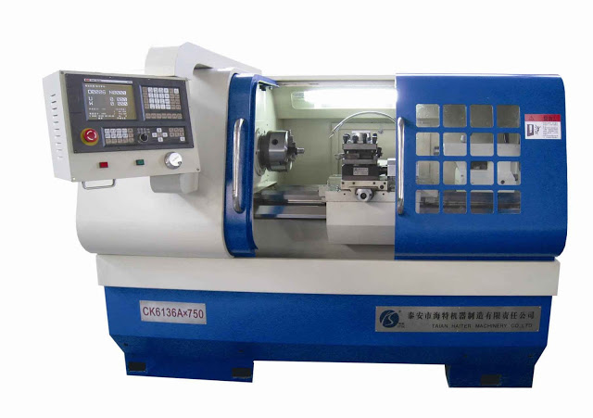](https://3.bp.blogspot.com/-mC_aONnXiEQ/WHTUL14IbjI/AAAAAAAAHtU/y-1EneDW1gkn_A3OKTGydFUYA_4aahCDQCLcB/s1600/what+is+cnc+machine.jpg)

### ****BLOCK DIAGRAM OF CNC MACHINE****

[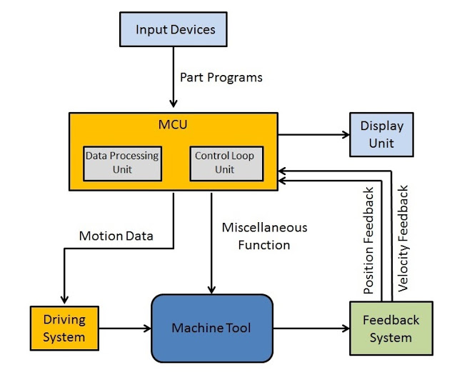](https://4.bp.blogspot.com/-VGZXfX4B88Y/WHTTY3AsdyI/AAAAAAAAHtQ/k3F0598lLLkFMXpdtgnFLMdHhWSP06K5wCLcB/s1600/Block+diagram+of+CNC+machine.jpg)

### ****MAIN PARTS OF CNC MACHINE****

The main parts of the CNC machine are

**(i) Input Devices:** These are the devices which are used to input the part program in the CNC machine. There are three commonly used input devices and these are punch tape reader, magnetic tape reader and computer via RS-232-C communication.

**(ii) Machine Control Unit (MCU):** It is the heart of the CNC machine. It performs all the controlling action of the CNC machine, the various functions performed by the MCU are

* It reads the coded instructions fed into it.
* It decodes the coded instruction.
* It implements interpolation (linear, circular and helical) to generate axis motion commands.
* It feeds the axis motion commands to the amplifier circuits for driving the axis mechanisms.
* It receives the feedback signals of position and speed for each drive axis.
* It implements the auxiliary control functions such as coolant or spindle on/off and tool change.

**(iii) Machine Tool:** A CNC machine tool always has a slide table and a spindle to control of the position and speed. The machine table is controlled in X and Y axis direction and the spindle is controlled in the Z axis direction.

**(iv) Driving System:** The driving system of a CNC machine consists of amplifier circuits, drive motors and ball lead screw. The MCU feeds the signals (i.e. of position and speed) of each axis to the amplifier circuits. The control signals are than augmented (increased) to actuate the drive motors. And the actuated drive motors rotate the ball lead screw to position the machine table.

**(v) Feedback System:** This system consists of transducers that act as sensors. It is also called a measuring system. It contains position and speed transducers that continuously monitor the position and speed of the cutting tool located at any instant. The MCU receives the signals from these transducers and it uses the difference between the reference signals and feedback signals to generate the control signals for correcting the position and speed errors.

**(vi) Display Unit:** A monitor is used to display the programs, commands and other useful data of CNC machine.

### ****HOW CNC MACHINE WORKS?****

* First, the part program is inserted into the MCU of the CNC.
* In MCU all the data process takes place and according to the program prepared, it prepares all the motion commands and sends it to the driving system.
* The drive system works as the motion commands are sent by MCU. The drive system controls the motion and velocity of the machine tool.
* The feedback system records the position and velocity measurement of the machine tool and sends a feedback signal to the MCU.
* In MCU, the feedback signals are compared with the reference signals and if there are errors, it corrects it and sends new signals to the machine tool for the right operation to happen.
* A display unit is used to see all the commands, programs and other important data. It acts as the eye of the machine.

### ****ADVANTAGES****

* It can produce jobs with the highest accuracy and precision than any other manual machine.
* It can be run for 24 hours a day.
* The parts produced by it have the same accuracy. There is no variation in the parts manufactured.
* A highly skilled operator is not required to operate it. A semi-skilled operator can also operate accurately and more precisely.
* Operators can easily make changes and improvements and reduce the delay time.
* It has the capability to produce complex designs with high accuracy in minimum possible time.
* The modern design software, allows the designer to simulate the manufacturer of his/her idea. And this removes the need for making a prototype or model and saves time and money.
* Fewer workers are required to operate a CNC and save labor costs.

### ****DISADVANTAGES****

Despite of having so many advantages, It has some disadvantages too. And these are:

* The cost of the CNC machine is very high as compared with a manually operated machine.
* The parts of the CNC machines are expensive.
* The maintenance cost in the case of CNC is quite high.
* It does not eliminate the need for costly tools.

### ****APPLICATION****

Almost every manufacturing industry uses CNC machines. With an increase in the competitive environment and demands, the demand for CNC usage has increased to a greater extent. The machine tools that come with the CNC are lathe, mills, shaper, welding, etc. The industries that are using CNC machines are the automotive industry, metal removing industries, industries of fabricating metals, electrical discharge machining industries, wood industries.

**Types of Words**

N - sequence number prefix

G - preparatory words

* + Example: G00 = PTP rapid traverse move

X, Y, Z - prefixes for *x*, *y*, and *z*-axes

F - feed rate prefix

S - spindle speed

T - tool selection

M - miscellaneous command

* + Example: M07 = turn cutting fluid on
* **CNC Lathe G Code List**

|  |  |
| --- | --- |
| **G code** | **Description** |
| G00 | Rapid traverse |
| G01 | Linear interpolation |
| G02 | Circular interpolation CW |
| G03 | Circular interpolation CCW |
| G04 | Dwell |
| G09 | Exact stop |
| G10 | Programmable data input |
| G20 | Input in inch |
| G21 | Input in mm |
| G22 | Stored stroke check function on |
| G23 | Stored stroke check function off |
| G27 | Reference position return check |
| G28 | Return to reference position |
| G32 | Thread cutting |
| G40 | Tool nose radius compensation cancel |
| G41 | Tool nose radius compensation left |
| G42 | Tool nose radius compensation right |
| G70 | Finish machining cycle |
| G71 | Turning cycle |
| G72 | Facing cycle |
| G73 | Pattern repeating cycle |
| G74 | Peck drilling cycle |
| G75 | Grooving cycle |
| G76 | Threading cycle |
| G92 | Coordinate system setting or max. spindle speed setting |
| G94 | Feed Per Minute |
| G95 | Feed Per Revolution |
| G96 | Constant surface speed control |
| G97 | Constant surface speed control cancel |

* **CNC Lathe M Code List**

|  |  |
| --- | --- |
| **M code** | **Description** |
| M00 | Program stop |
| M01 | Optional program stop |
| M02 | End of program |
| M03 | Spindle start forward CW |
| M04 | Spindle start reverse CCW |
| M05 | Spindle stop |
| M08 | Coolant on |
| M09 | Coolant off |
| M29 | Rigid tap mode |
| M30 | End of program reset |
| M40 | Spindle gear at middle |
| M41 | Low Gear Select |
| M42 | High Gear Select |
| M68 | Hydraulic chuck close |
| M69 | Hydraulic chuck open |
| M78 | Tailstock advancing |
| M79 | Tailstock reversing |
| M94 | Mirrorimage cancel |
| M95 | Mirrorimage of X axis |
| M98 | Subprogram call |
| M99 | End of subprogram |

**Part Program:**

**N10 G28 X0.0 Z0.0;**

**N20 M06 T0101;**

**N30 G97 S800 M03;**

**N40 G21 G90;**

**N50 G95;**

**N60 G00 X52.0 Z5.0 M08;**

**N70 G00 X49.0 Z1.0;**

**N80 G01 X49.0 Z-40.0 F0.2;**

**N90 G00 X52.0 Z1.0;**

**N100 G00 X48.0;**

**N110 G01 Z-40.0;**

**N120 G00 X52.0 Z1.0;**

**N130 G00 X47.0;**

**N140 G01 Z-40.0;**

**N150 G00 X52.0 Z1.0 M09;**

**N160 G28 X0.0 Z0.0;**

**N170 M05;**

**N180 M30;**